**Data Collection and Preprocessing Phase**

|  |  |
| --- | --- |
| Date | 6 October 2025 |
| Team ID | xxxxxx |
| Project Title | Predicting Plant Growth Stages with Environmental and Management Data Using Power BI |
| Maximum Marks | 3 Marks |

**Data Quality Report Template**

The Data Quality Report Template will summarize data quality issues from the selected source, including severity levels and resolution plans. It will aid in systematically identifying and rectifying data discrepancies.

1. Data Source and Scope

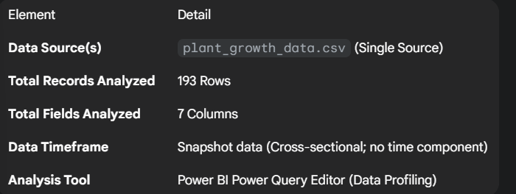

**2. Data Integrity and Completeness Analysis**

The dataset exhibits **high completeness and integrity**, requiring minimal preprocessing for core analysis.

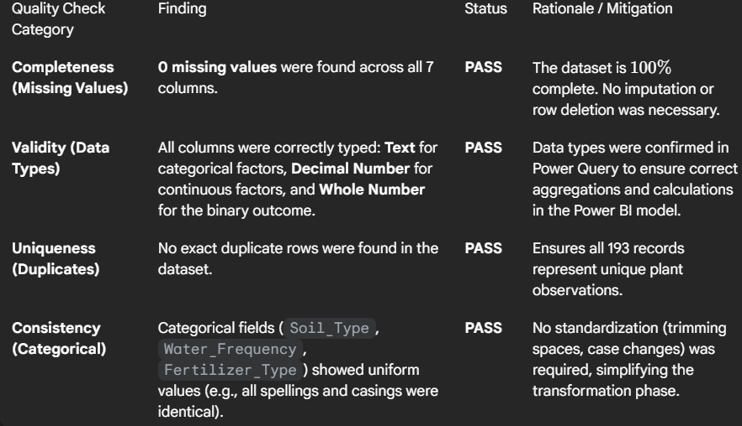

**3. Data Profile and Statistical Review**

A review of the continuous variables confirms they fall within expected physical ranges and show no significant anomalies.

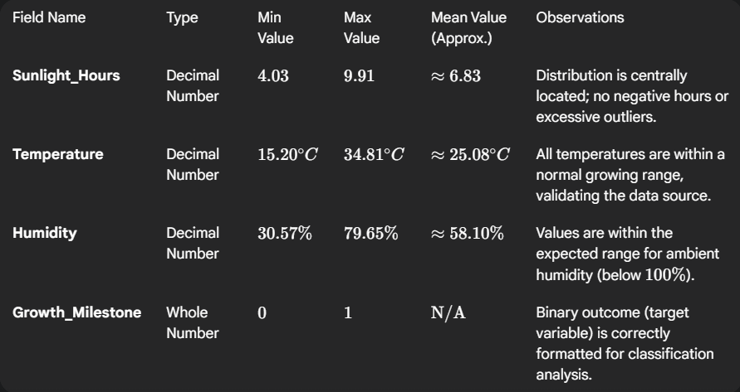

**4. Conclusion and Preprocessing Actions**

**Summary:** The plant_growth_data.csv is of **high quality** and requires **minimal cleaning**. The primary preprocessing effort will not focus on fixing errors but on **enhancing usability** for the Power BI dashboard.

**Required Preprocessing Actions:**

1. **Binning:** Creation of the **Sunlight_Hour_Bins** custom column in Power Query to transform continuous data into categorical bins for histogram visualization.
2. **User-Friendly Column:** Creation of the **Growth_Status** calculated column (using DAX) to translate the binary outcome () into clear labels ("Milestone Reached"/"No Milestone").
3. **Measure Creation:** Definition of key DAX measures like **Success_Rate** for dashboard display.